**Composite of Charts Explained and Discussion**

**Chart 1:** Comparison of Home vs. Away Team Statistics

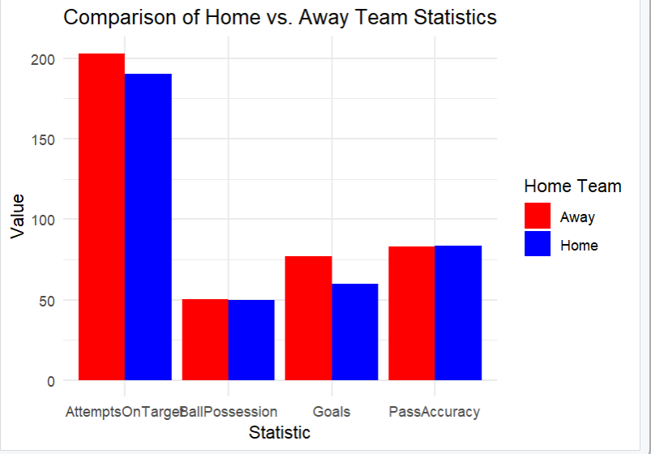

This clustered bar chart compares multiple football team performance metrics (Goals, Attempts on Target, Ball Possession, Pass Accuracy) between home and away teams. As can be seen in the chart, away teams demonstrate a clear advantage in attempts on target and goals, witch the outcome is challenging traditional notion and opposite to the finding of Leite (2017), who claims home team usually have better team statistics. While in ball possession and pass accuracy, both home and away teams exhibit similar patterns, indicating home teams no longer exhibit a significant tactical advantage during matches without crowds. This chart implies that away teams may take advantage of the absence of crowd to mitigate home advantage.

**Chart 2.** Ball Possession vs. Goals Scored

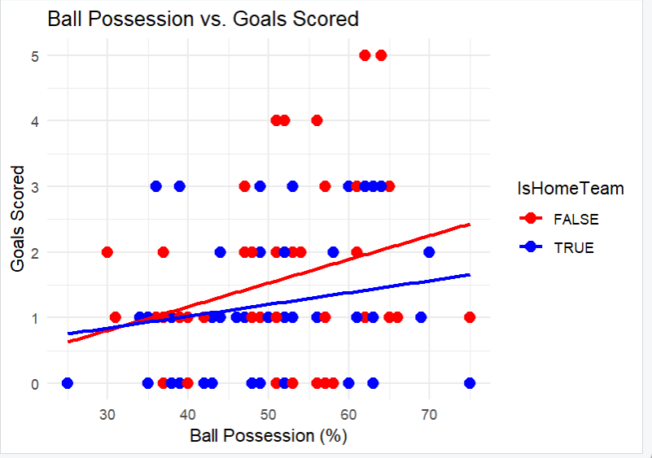

Chart 2 reveals the relationship between ball possession and goals scored for home and away countries with different regression lines to indicate trends. This scatter plot shows a stronger positive correlation for away teams, suggesting away teams were more effective in converting possession into goals. As for home team, the regression line demonstrates a weaker correlation, possibly indicating the critical role of crowd effects in promoting the performance of home teams. This chart implies that the absence of crowd for home teams may even let home advantage become “away advantage”.

**Chart 3:** Proportion of Matches Won

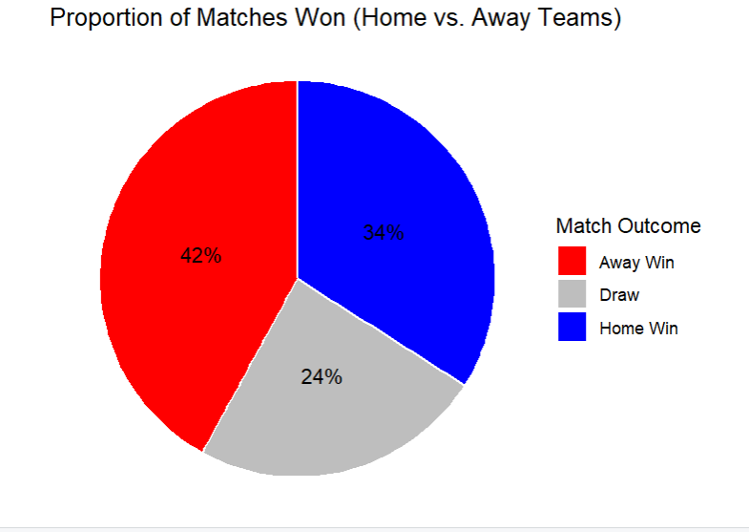

This pie chart illustrates the distribution of the match outcomes of UEFA Euro 2020 and give a good intuitive look of winning rate. According to the chart, the win rate of away team outnumbers the home team’s, which represents the effect of home advantage completely reversed due to the influence of pandemic. This chart could be good to show that the losing environmental benefits of home team may lead to the reversal of situation.

**Chart 4.** Distribution of Yellow and Red Cards

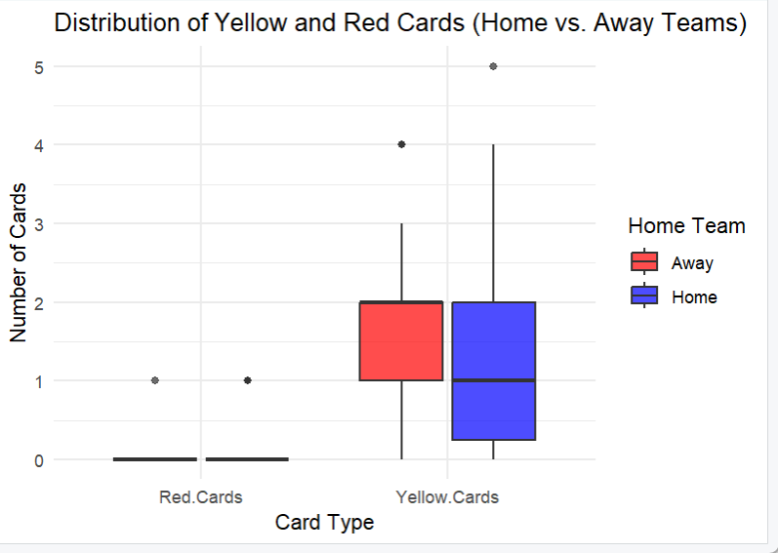

The box plot compares yellow and red cards received by home and away teams. The plot demonstrates that both home and away teams almost did not receive red card. As for yellow cards, home teams received slightly fewer yellow cards but had bigger variability. It can be concluded that referee’s bias of decision making that affected by environmental factors was obviously mitigated, under the condition of pandemic (Sors et al., 2021).

These findings indicate that the absence or decreased number of spectators neutralised traditional home advantage factors. Additionally, another insight about “home advantage” under the condition of COVID-19 pandemic, showing the results of football match changed significantly when the environment changed dramatically was provided.